BEGINNING MUSICAL TERMS & DEFINITIONS
Personal Progress Tracker

INSTRUCTIONS:

As you become familiar with each term and its symbol and name, shade in the boxes next to it according to the following scale:

- I don’t know what this is.
- I can tell the meaning of this.
- I can write this, draw it, and tell the meaning.
- I can find examples of this in real music and teach it to a friend.
- I knew this all last time and I still remember it without being reminded.
BEGINNING MUSICAL TERMS & DEFINITIONS
Personal Progress Tracker

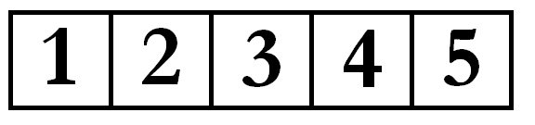
“A TEMPO”: return to the original tempo

Accelerando: to get faster
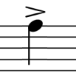
Accent: to emphasize a note

ARTICULATION: the style in which you perform the notes

Audiate: hearing a pitch in your head.

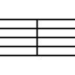
barline: vertical lines that separate measures.

clef: helps organize the staff so notes can be easily
read

Crescendo: to get louder
Decrescendo: to get softer

dot: 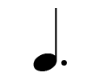 adds half the original value to the note

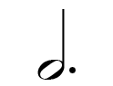
dotted half note: 3 beats

dotted half rest: 3 beats of silence

dotted quarter note: 1.5 beats

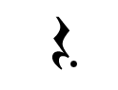dotted quarter rest: 1.5 beats of silence

double bar line: shows the end of the song or section

DYNAMICS: the volume of the music
eighth note: .5 beats

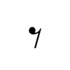eighth rest: .5 beats of silence

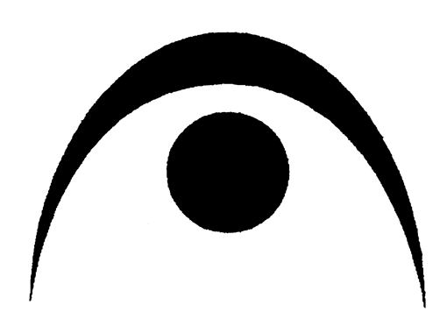
Fermata: hold the note and watch the conductor

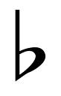
Flat: lowers the pitch be one half step
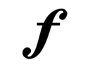
Forte: loud
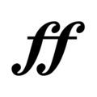
Fortissimo: very loud

Grand staff: bass and treble staff connected by a brace and a line

half note: 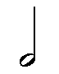 2 beats
half rest: 2 beats of silence

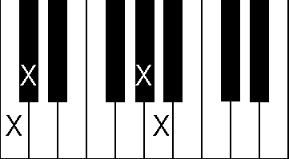
Half step: the distance from any key on the keyboard to the very “the next key above or below, whether black or white”

HARMONY: notes that compliment the melody

Interval: distance between two notes

Key Signature: sharps or flats at the beginning of music to indicate scale and tonality

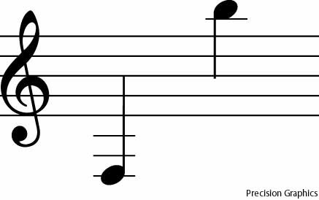Ledger line: short lines that are added to extend the range of the staff when the notes are too low or too high to be written on the staff

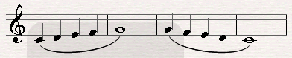
Legato: smooth and connected

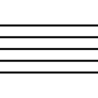
Lines: Lines on treble clef (EGBDF)
Lines on bass clef (GBDFA)

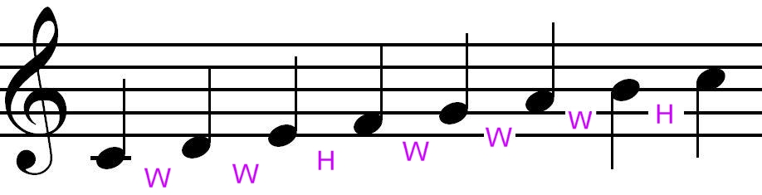Major Scale: scale built on the formula (WWHWWWH)

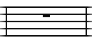
measure: music between two bar lines

MELODY: the main tune of a song

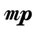Mezzo Forte: medium loud
Mezzo Piano: medium soft
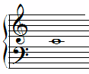
Middle C: the note in the middle of the grand staff and the C nearest the middle of the keyboard

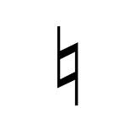
Natural Sign: the natural sign before a note cancels a previous flat or sharp
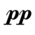Notes: the oval-shaped symbols that are placed on the lines and in the spaces of the staff. They represent musical sounds called pitches
Pianissimo: very soft
Piano: soft

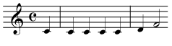
pick up: a note before the first complete measure

Pitch: a musical sound
quarter note: 1 beat

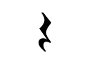
quarter rest: 1 beat of silence

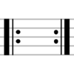
Repeat Sign: return to the beginning or previous repeat sign at the beginning of a section

RHYTHM: division of a steady beat

Ritardando: to get slower
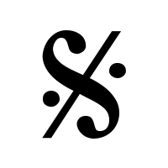
Segno: a musical sign that marks a section; used with repeats

Sharp: raises the pitch by one half step
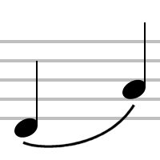
Slur: a curved line drawn over or under two or more notes of different pitches
Solfege: do re mi fa sol la ti do a system of reading musical notes by assigning a different syllable to each note
Spaces: spaces on treble clef (DFACEG);
spaces on bass clef (FACEGB)

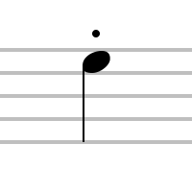
Staccato: short and detached; notated as a dot above or below a
note
Staff: horizontal lines and spaces on which music is written

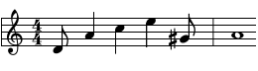
syncopation: accenting the off-beat

TEMPO: the speed of the music

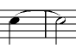
tie: asdf a curved line that combines two notes of the same pitch and adds their value together.
combines two notes of the same pitch together

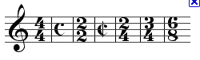time signature: top number: number of beats per measure
bottom note: which type of note gets the beat
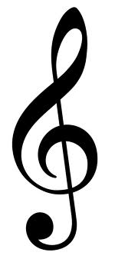
Treble or G clef: the clef used for notes in the higher pitch
range

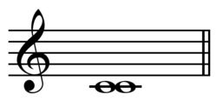
Unison: interval between two identical notes;
unison singing is when everyone is singing the same pitches
Whole note: whole measure, 4 beats

Whole rest: whole measure, 4 beats of silence

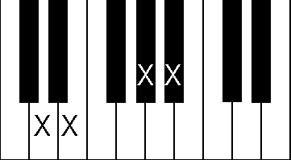
Whole step: the distance from any key on the keyboard to two keys away

